

Elizabeth Raum Phone: 701-516-6705
Email: Elizabeth@elizabethraumbooks.com
Website: http://elizabethraumbooks.com/

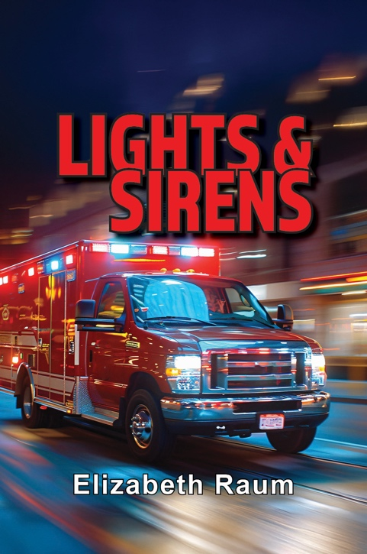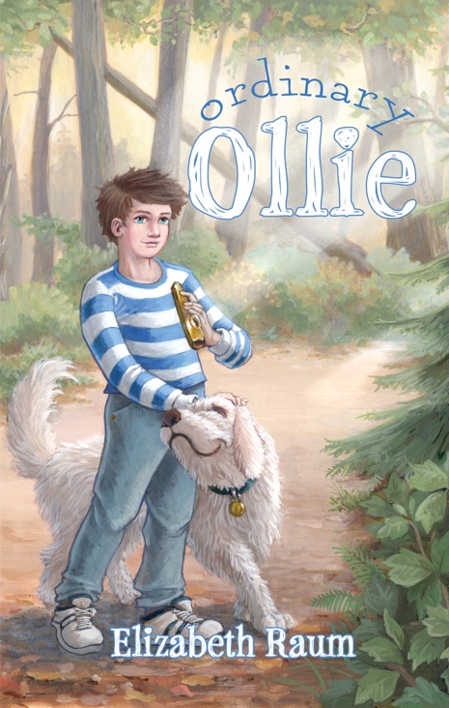

Brief Bio

Elizabeth Raum has written more than 160 books for young readers and two books for adults. New in 2026 is Lights & Sirens, a YA novel. Forthcoming in November 2026 is the middle-grade novel, Ordinary Ollie. Several of her books have earned 5-Star Reviews from Readers Choice, and have been Junior Library Guild choices. The Big, Bold, Adventurous Life of Lavinia Warren was selected as a Best Social Studies Book by the Children’s Book Council. Raum lives in Greeneville, Tennessee. Visit her website at: www.elizabethraumbooks.com

Longer Bio

Elizabeth Raum has been a teacher, an elementary school and college librarian, and is currently a full-time writer. She has written more than 160 books for young readers and two books for adults. New in 2026 is Lights & Sirens, a YA novel. Forthcoming in November 2026 is the middle-grade novel, Ordinary Ollie. Recently published novels include middle-grade historical fiction books Boy With A Fife: Ebenezer Fletcher’s War of Independence and A Kidnapping in Kentucky, 1776. Several of her books have been Junior Library Guild choices and have earned 5-Star Reviews from Readers Choice. The Big, Bold, Adventurous Life of Lavinia Warren was selected as a Best Social Studies Book by the Children’s Book Council. She has written interactive historical novels about American history and world history. Her interactive Bible series, Choose Your Journey, introduces readers to life in the first century.
Raum lives in Greeneville, Tennessee. Visit her website at: www.elizabethraumbooks.com

A LOOK AT RECENT BOOKS
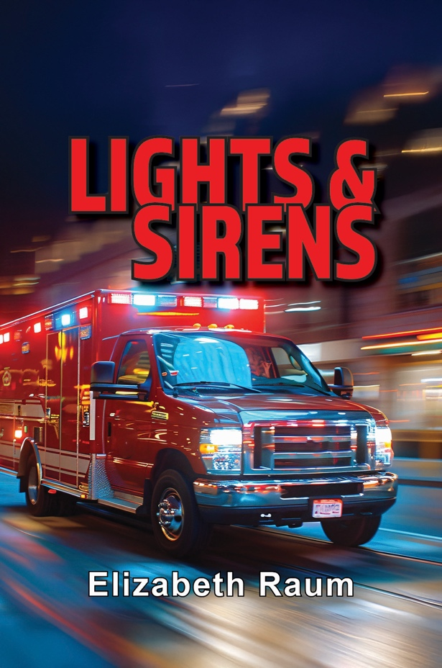
Lights and Sirens (published 2026 by Elk Lake Publishing)

Contemporary Novel for ages 12 +

Review by Robert A. Groves of Readers' Favorites:

“Lights & Sirens by Elizabeth Raum is a heartwarming tale about Annika “Anni” Sawyer, a quiet sixteen-year-old still dealing with herdad’s death. After seeing a poster in a store window for volunteers, Anni decides to join her town’s ambulance squad. At first, Anni wants to help people and maybe find a sense of purpose. But the
job quickly teaches her that saving others is not simple or easy. It is hard work. She sees pain and loss up close, and those experiences begin to force her to face her own grief. Along the way, Anni grows close to the other crew members. There’s Ruby, Wilbur, and Jesse,a quiet EMT who loves poetry. In time, Anni learns that helping
others cannot completely erase what hurts inside, but it can begin to heal her.

As I read Elizabeth Raum’s Lights & Sirens, the descriptive phrase that kept coming to mind was “heavy laden.” Anni’s story has all the feels. I cried, laughed, cursed, and did it all over again. My main takeaway was that life happens one moment or event at a time. Of course, some of the emergency call scenarios hit harder than others. This was especially true for scenes that involved Jesse. Anni’s personal connection with him was a high point of the book. Their friendship really illustrated what it means to show up for another. Drawing on Jesse’s love of poetry, the incorporation of his writing into the plot was a brilliant move that elevated the read. I highly recommend Raum’s novel to young adult readers who like characters with heart and who are experiencing personal growth.”

One Teen Reviewer Wrote:

“Lights & Sirens carefully and skillfully explores connection and the weight carried by the characters in meaningful, authentic, and relatable ways for the readers. Under the tension and action, there's a lot of heart in this story, and I found myself thinking about it long after I had shut the cover on the final page.

Overall, I found Lights & Sirens an engaging, memorable read. So if you love emotional, action packed and character driven stories, then this book is for you!”

Another Teen Wrote:

“I extremely enjoyed reading Lights and Sirens. I read the entire 266-page book in one afternoon! I could not put it down, even when I knew I had final exams to study for. I plan to pursue EMT-B certification in the next few years. This book fueled the fire! I would definitely volunteer with my local first responders. Lights and Sirens is a truly inspiring read. Readers can tell the author has done her research with this book. I also appreciate her discretion when writing about wacky calls; I don’t have to worry if my nine-year-old sister picks this novel up. Ms. Raum writes with appropriate language for all ages.”

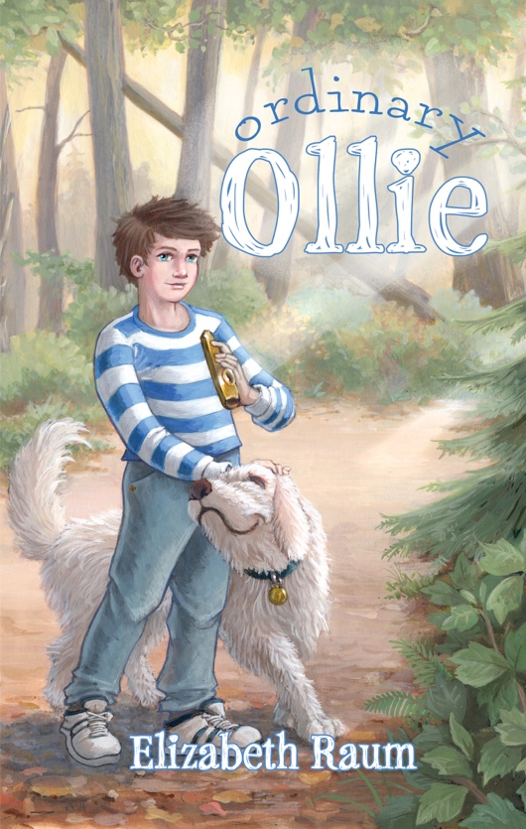
Ordinary Ollie (Chicken Scratch Press, 2026)

Magical Realism for ages 8-12
Oliver’s parents were famous, his sisters brilliant. But Ollie? Oh, he could bark like a dog, tweet like a bird, and howl like the wind, but his mimicry didn’t impress his family. He longed for a talent worthy of their respect.
But then, on his 12th birthday, something extraordinary happened. Ollie gained a superpower – INVISIBILITY. If he could figure out how to use it, he’d never be ordinary again.
New friendships bring new experiences, and Ollie finds himself wondering if talents and superpowers really mean what he thought they meant.
Maybe Ordinary Ollie is exactly who the world needs.

ONE REVIEWER WROTE:

“Beautiful story about Ollie Hope, who feels he is just ordinary in comparison to his extraordinary family. His parents and sisters all have special talents — artist, mathematician, inventor, and pianist. All he can do is imitate sounds, which is unimpressive to his accomplished family. An unexpected gift gives him an extraordinary super power that turns out to be not as wonderful as he expected. When he has the chance to use his unique talents to help his new neighbors, the community, and thwart a crime, he finds the courage to be himself and find his place in his family. A great story for all of us who have at some time felt ordinary or overlooked. Highly recommend this book for beginning readers and families.”

ANOTHER WROTE:

“Ollie comes from a family of extraordinary people. His father is a brilliant inventor, his mother is a talented artist, and his sisters are a math genius and a gifted pianist, respectively. His own talents, like mimicry, seem useless and dull by comparison, and he is given the nickname "Ordinary Ollie" by his family, and his only real friend is his dog Pokey. Everything seems poised to change when he discovers that a magical kazoo he was given grants him the power of invisibility.
This is a very classic-feeling middle grades novel with a likable protagonist finding his wings and discovering that he isn't as ordinary as he believes. Perhaps the most remarkable element is its restraint. Though the kazoo looks like the inciting incident that starts Ollie's journey of self-discovery, it's the friendship he makes with his new neighbor Gabby a few chapters later that really sets the stage for this story. And while a magic kazoo that can turn you invisible suggests the beginning of superheroic antics, uncovering conspiracies and thrilling chases, this story isn't interested in any of that. There is (mild spoilers) a bank robbery about halfway through, but ultimately you'll find no truly fantastical adventures, just a sweet and grounded story of how his friendship with Gabby enables Ollie to actualize all the ways he's already extraordinary.
There are some explicitly Christian elements, but nothing overbearing or preachy. Overall, this is a sweet and very enjoyable story for all ages!”

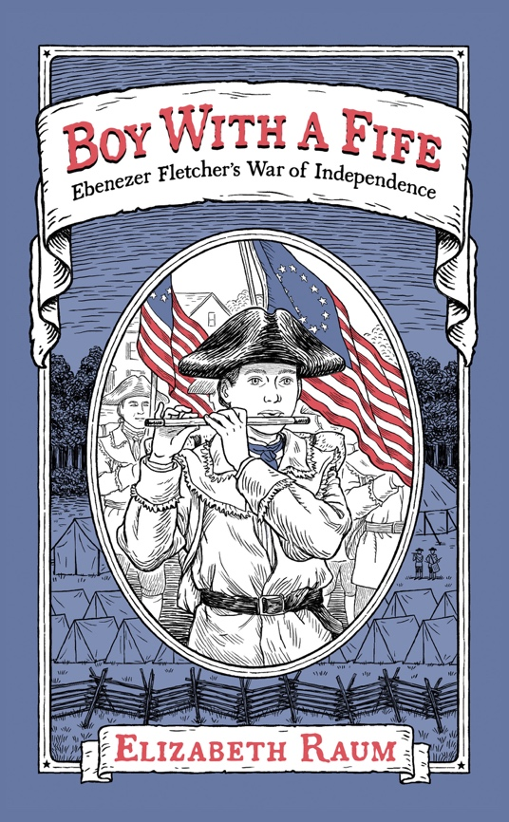
Boy With A Fife: Ebenezer Fletcher’s War of Independence (Chicken Scratch Press, 2024)

Historical Fiction for ages 9-14.

As a young lad, Ebenezer Fletcher played war games with other boys in New Ipswich, New Hampshire. In April 1775, his life changed forever when British soldiers attacked the towns of Lexington and Concord. Shots were fired. Men died. War was no longer a children's game.

When the New Ipswich militia responded to the attack, thirteen-year-old Ebenezer joined them, playing his fife on the long march to Boston. During the next few years, Eb faced dangers and hardships, both at battle and at home. He played his fife for the militia, aided the injured, worked as an apprentice, and at age fifteen, joined the Continental Army. During a battle, he was wounded and captured by the British. Courage and determination never deserted him. Through it all, he remained focused on his goal - Liberty.

This is his story.

MIDWEST BOOK REVIEW: Although a work of carefully crafted historical fiction, “Boy With a Fife: Ebenezer Fletcher’s War of Independence” by Elizabeth Raum is based on the autobiography of Ebenezer Fletcher, who as a boy participated in the American Revolution and lived to tell about it. A fun and fascinating read from start to finish, “Boy With a Fife” is especially and unreservedly recommended for elementary school, middle school, and community library Historical Fiction collections for young readers ages 9-12. It should be noted for personal reading lists that this paperback edition of “Boy With a Fife” from Chicken Scratch Books is also readily available in a digital book format (Kindle, $4.99).
JOHN NETH (Color Guard Commander of the Kings Mountain Chapter, Tennessee Society, Sons of the American Revolution, and presenter on Revolutionary War Soldier, primarily Militia) writes: “Boy with a Fife is well written and in short chapters which will keep the attention of the young student. The factual items are interlaced with what could have been conversations Eb had with a number of individuals along the way. I would highly recommend this book to any student studying our fight for Independence, especially as we enter the 250th year anniversary of our Declaration of Independence.”
GARY VORWALD (Fife Major, 22nd Regiment of Foot, Brigade of the American Revolution) writes: “As a historian of military music and the American Revolution, I found this story particularly engaging. I have researched the role of fifers and drummers during this pivotal time in American history and co-authored the book Military Music of the American Revolution (Brigade of the American Revolution, 2007), which features fife and drum music from the period. I am greatly impressed by the attention to detail and the accurate depiction of the role of a fifer. The book is rich in historical facts and is entertaining and educational. In many ways, this book is reminiscent of Johnny Tremain, but Boy With a Fife is based on a true story. Middle-grade readers should be able to identify with Ebenezer as someone close to their age who faced hardships while serving his country during wartime. Through this story, they will gain meaningful insights into aspects of the War for Independence. This work is an outstanding literary accomplishment about the American Revolution for middle grade-readers.”
FARGO (ND) FORUM REVIEW: [Boy With A FIfe] is an exciting tale of heroism, patience, family patriotism, and the harsh realities of war without unnecessary gore or gratuitous violence.
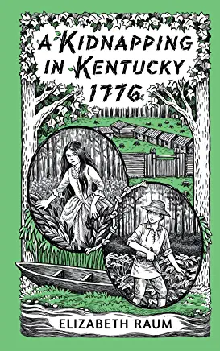
A Kidnapping in Kentucky, 1776 (Chicken Scratch Press, 2022)

Historical Fiction for ages 8-12.

The Kentucky frontier was a beautiful place, but also a dangerous one. Jemima Boone and John Gass often heard wolves howling, bears growling, and snakes slithering through the tall grasses. There was no store, no school, no doctor at Fort Boonesborough. The settlers were on their own to deal with whatever threats arose.

On a sunny summer day in July of 1776, the crisis they faced was a kidnapping . . . based on a true event.

BASED ON A TRUE EVENT!

c
Complete novel units are available for all Chicken Scratch Books from the publisher.

Reviewers write:
☆☆☆☆☆5 out of 5 stars.
"Makes Me Curious About History -- This is the story of the kidnapping of Daniel Boone's daughter. Although this is a fictionalized version of what happened in 1776, it really makes me want to dig deeper about the history of that period in time. Luckily, the back of the book includes a timeline, questions and answers, glossary, and a list of sources for further exploration."

☆☆☆☆☆☆☆☆☆☆5 out of 5 stars
"A True, Thought-Provoking Story --
A KIDNAPPING IN KENTUCKY by Elizabeth Raum begins on a lazy Sunday afternoon in Boonesborough. The exciting true events that follow are shared in alternating chapters through the perspectives of Jemima Boone, the kidnapped girl, and twelve-year-old John Gass, her friend. The supporting detail from Raum's impeccable research grounds the story . . . As she wrote in her author's note: 'Fights between frontier settlers and various American Indian tribes are a fact of history. These are often sad stories. Entire communities were destroyed on both sides. It's tempting to pretend that this did not happen. But it did. Learning about our history, understanding not only what happened but why, helps us to make better decisions in the future.'"

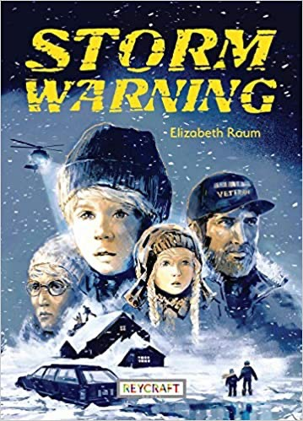
Storm Warning (Published Reycraft Books, 2021)

Historical fiction for ages 8-12)

No matter how hard twelve-year-old North Olson tries to do what’s right, he can’t seem to please his dad. When a major flood threatens to destroy his hometown, North is left in charge of his little sister Rosie. A blizzard blows in and his great-grandmother disappears. Can North find his great-grandmother and keep Rosie safe as the flood waters continue to rise? Will he finally make his dad proud?

This story takes place in the Red River Valley of the North during the 1997 flood. Its fiction based on the natural disaster that took place throughout the region. Storm Warning is a Junior Literary Guild Gold Star selection.
One reviewer said: “STORM WARNING is absolutely riveting. I felt so involved with North and Rosie (and Grandma Lily and Dog), that I couldn't put the book down until their dreadful predicament was resolved.”
Soon to be published in Spanish.

****************************************************

The Choose Your Journey Series Published by JourneyForth Books.

These interactive Bible novels take readers to the first century where they encounter Jesus, the disciples, and various Biblical characters. Readers must make choices as they read. The books are designed for readers ages 7-9. The books can be purchased as a set or individually.

Teacher Anitra Ollison writes: "I love how Ms. Raum allows the reader the choice of choosing different story plots based on the three characters' perspectives. Even a reluctant reader would enjoy reading a story adventure!"
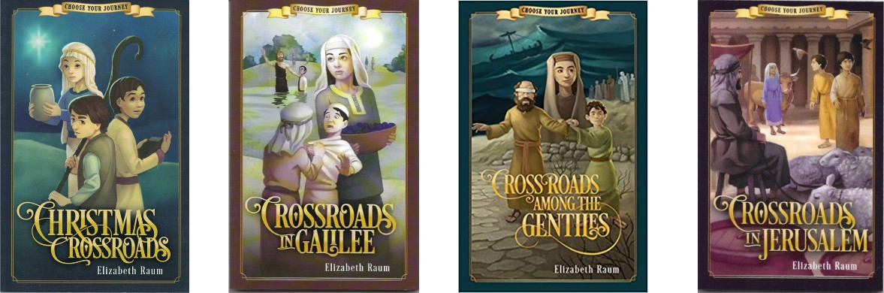

Another reviewer wrote of Crossroads in Jerusalem: “This was another fantastic book I received from JourneyForth books. I have 3 children from the ages of 4-9 and the smaller ones listened while they played and the older one helped me choose which way the story would go. Fantastic read and I hope to get the others in this series as

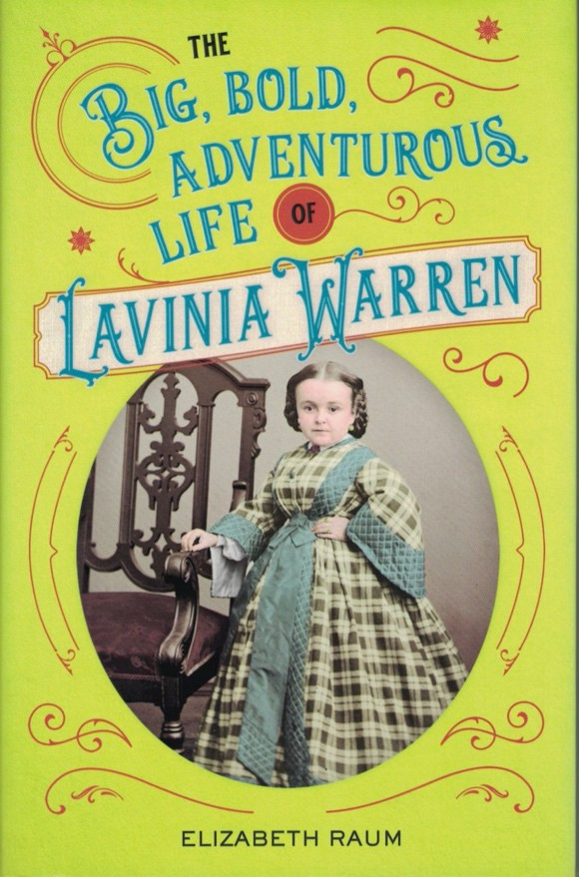
The Big, Bold, Adventurous Life of Lavinia Warren
(published by Chicago Review Press, 2018

Biography for ages 10+

Lavinia Warren never grew taller than 32 inches, but she lived life large. Her wedding to Tom Thumb (Charles Stratton) was the first celebrity wedding. They toured the world together and entertained thousands. With additional material on Tom Thumb Weddings, readers' questions, time line, and notes and bibliography, this is sure to be a valuable title for adventurous middle-grade readers.

Chosen by the Children’s Book Council as a “Best Book for the Social Studies” 2018.

9/1/18 -- Midwest Book Review, "The Big, Bold, Adventurous Life of Lavinia Warren by Elizabeth Raum is an unreservedly recommended addition to family, elementary school, and community library biography collections for young readers ages 8 to 12.”

For a complete listing of Elizabeth Raum publications, please visit her website: www.elizabethraumbooks.com

